**VISVESVARAYA TECHNOLOGICAL UNIVERSITY**

**BELAGAVI-590018**

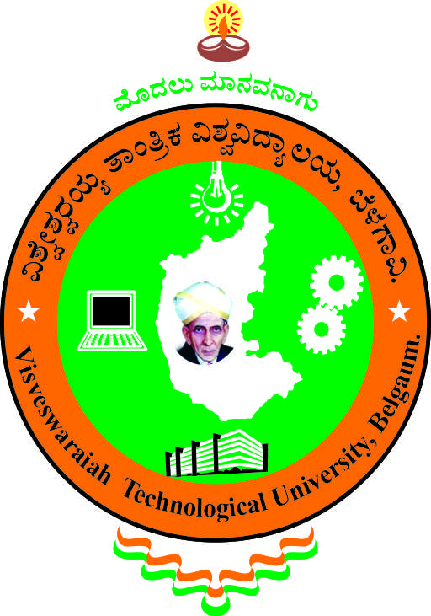

An Internship Report on

**“PREDICT FUEL EFFICIENCY USING TENSORFLOW IN PYTHON”**

Submitted in Partial Fulfillment of the award of the

Degree of Bachelor of Engineering

in

ELECTRONICS AND COMMUNICATION ENGINEERING

***Submitted by***

NAVEEN N NAGANURI

(2JI20EC072)

***Internship carried out***

***at***

**Cranes Varsity, Bangalore**

**Internal Guide External Guide**

Dr.Rajashekhargouda Patil Mr. Hemesh Muniraju

Professor, Designation:DataAnalyst

Dept,of ECE,JCE Belagavi



DEPARTMENT OF ELECTRONICS AND COMMUNICATION ENGINEERING

JAIN COLLEGE OF ENGINEERING

BELAGAVI**–** 590 014

2023-2024

**JAIN COLLEGE OF ENGINEERING,**

**BELAGAVI-590 014**



**Department of Electronics and Communication Engineering**

**CERTIFICATE**

Certified that the Internship entitled “**PREDICT FUEL EFFICIENCY USING TENSORFLOW IN PYTHON”,** is carried out by **Mr. Naveen N Naganuri, USN:2JI20EC072** a bonafide student of **Department of Electronics and Communication Engineering, Jain College of Engineering, Belagavi**, in partial fulfilment for the award of **Bachelor of Engineering** in Electronics and Communication Engineering of the **Visvesvaraya Technological University, Belagavi**, during the year **2023-2024**. It is certified that all corrections/suggestions indicated for Continuous Internal Evaluation have been incorporated in the report. The internship report has been approved as it satisfies the academic requirements in respect of Internship prescribed for the said Degree.

**Guide HOD Principal & Director** Dr.Rajashekhargouda Patil Dr.Krupa R.Rasane Dr. J. Shivakumar

Name of the examiners Signature with date

1. _________________________ __________________

2. __________________________ __________________

**DECLARATION**

I ***Mr. Naveen N Naganuri***, hereby declare that my Internship is carried out at “WONDERSYS AUTOMATIONS” with entitled ***“PREDICT FUEL EFFICIENCY USING TENSORFLOW IN PYTHON”*,** submitted by me to the Department of Electronics and Communication Engineering, Jain College of Engineering, Belagavi, under the supervision of **Prof. Rajashekhargouda Patil**. The report is for academic purpose.

**Mr. Naveen N Naganuri**

**(USN NO:2JI20EC072)**

Date: 3/11/2023

Place: Belagavi



**Jain College of Engineering, Belagavi**

***Department of Electronics and Communication***

**Department VISION**

“To achieve excellence in education and research for developing globally competent, ethically sound Electronics & Communication Engineers”

**Department MISSION**

1. To provide a conducive environment for learning through structured student centric, teaching-learning process
2. To nurture needs of society by infusing scientific temper in students and to grow as a centre of excellence with efficient industry-institute interaction
3. To inculcate self learning skills, entrepreneurial ability and professional ethics

**Program Educational Objectives (PEO)**

Graduates will be able to:

PEO1: Contemplate real-time social problems and deliver efficient

solutions.

PEO2: Lead and succeed in professional careers.

PEO3: Contribute through research and entrepreneurship.

**Program Specific Outcomes (PSO)**

Graduates in the UG program in Electronics and communication engineering will be able to:

1. Design, verify and develop analog and digital systems by using state of art technology to contribute to the societal needs.
2. Apply the knowledge in various domains of IoT, real time systems, communication systems, VLSI and embedded systems, image and signal processing using hardware and software tools.



**Jain College of Engineering, Belagavi**

***Department of Electronics and Communication***

Electronics Engineering Graduates will be able to achieve the following:

**1. Engineering knowledge:** Apply the knowledge of mathematics, science, and engineering fundamentals to the solution of Electronics engineering problems.

**2. Problem analysis:** Identify, formulate, review research literature, and analyze complex engineering problems reaching substantiated conclusions using first principles of mathematics, natural sciences, and engineering sciences.

**3. Design/development of solutions:** Design solutions for engineering problems and design system components or processes that meet the specified needs with appropriate for the public health and safety, and the cultural, societal, and environmental considerations.

**4. Conduct investigations of complex problems:** Use research-based knowledge and research methods including design of experiments, analysis and interpretation of data, and synthesis of the information to provide valid conclusions.

**5. Modern tool usage:** Create, select, and apply appropriate techniques, resources, and modern engineering and IT tools including prediction and modeling to complex engineering activities with an understanding of the limitations.

**6.The engineer and society:** Apply reasoning informed by the contextual knowledge to assess societal, health, safety, legal and cultural issues and the consequent responsibilities relevant to the professional engineering practice.

**7.Environment and sustainability:** Understand the impact of the professional engineering solutions in societal and environmental contexts, and demonstrate the knowledge of, and need for sustainable development.

**8. Ethics:** Apply ethical principles and commit to professional ethics and responsibilities and norms of the engineering practice.

**9. Individual and teamwork:** Function effectively as an individual, and as a member or leader in diverse teams, and in multidisciplinary settings.

**10. Communication:** Communicate effectively on complex engineering activities with the engineering community and with society at large, such as, being able to comprehend and write effective reports and design documentation, make effective presentations, and give and receive clear instructions.

**11. Project management and finance:** Demonstrate knowledge and understanding of the engineering and management principles and apply these to one’s own work, as a member and leader in a team, to manage projects and in multidisciplinary environments.

**12. Life-long learning:** Recognize the need for, and have the preparation and ability to engage in independent and life-long learning in the broadest context of technological change.



|  |  |
| --- | --- |
| **Subject : Internship** | **Subject Code:18ECI85** |
| **Course Objectives:**  1: Exposure to the current technological developments relevant to the subject area of training  2. Learn to apply the Technical knowledge in real industrial situations.  3. Gain experience in writing Technical reports/projects  4. Expose students to the engineer’s responsibilities and ethics.  5. Expose the students to future employers | |
| **CO-PO/PSO Mapping:**  **L1: Remembering L2: Understanding L3: Applying L4: Analyzing L5: Evaluating L6: Creating**   |  |  |  | | --- | --- | --- | | **Course Outcomes** | **Description** | **Bloom’s Cognitive level** | | 18ECI85.1 | Articulate and apply principles learned in the class rooms to specific internship site experience | L3 | | 18ECI85.2 | Develop work competencies for a specific profession or occupation. | L3 | | 18ECI85.3 | Will be able to use modern tools and processes to solve the problems | L3 | | 18ECI85.4 | Present thoughts and ideas clearly and effectively. (Oral and written communication, report writing, presentation skills). | L3 | | 18ECI85.5 | Explore career options and gain general work experience | L3 |   **Strength of CO Mapping to PO/PSOs with Justification:**  1: Slight (Low) 2: Moderate (Medium) 3: Substantial (High)     |  |  |  |  |  |  |  |  |  |  |  |  |  |  |  | | --- | --- | --- | --- | --- | --- | --- | --- | --- | --- | --- | --- | --- | --- | --- | | **COs** | **PO1** | **PO2** | **PO3** | **PO4** | **PO5** | **PO6** | **PO7** | **PO8** | **PO9** | **PO10** | **PO11** | **PO12** | **PSO1** | **PSO2** | | 18ECI85.1 | **2** | **1** |  |  |  |  |  |  |  |  |  |  |  |  | | 18ECI85.2 | **1** | **2** | **1** |  |  | **1** |  |  |  |  |  |  |  |  | | 18ECI85.3 | **1** | **1** |  |  | **2** |  |  |  |  |  |  |  |  |  | | 18ECI85.4 |  |  |  |  |  |  |  |  | **1** | **2** |  |  |  |  | | 18ECI85.5 |  |  |  |  |  |  |  | **1** |  |  |  | **2** |  |  | | **Avg** | **0.667** | **0.667** | **0.2** |  | **0.4** | **0.2** |  | **0.2** | **0.2** | **0.4** |  | **0.4** |  |  | | |

**Jain College of Engineering, Belagavi**

***Department of Electronics and Communication***



**Jain College of Engineering, Belagavi**

***Department of Electronics and Communication***

|  |  |  |
| --- | --- | --- |
| **CO-PO** | | **Justification** |
| CO-1 | PO1-(2) | Students will gain the engineering knowledge |
| PO2(1) | Students will analyze and solve the problem with different tools |
| CO-2 | PO1 (1) | Students will gain the engineering knowledge |
| PO2(2) | Students will analyze and solve the problem with different tools |
| PO3(1) | Students will be able to develop prototypes for different applications. |
| PO6(1) | Students will be able to develop professional engineering practice. |
| CO-3 | PO1 (1) | Students will gain the engineering knowledge |
| PO2(1) | Students will analyze and solve the problem with different tools |
| PO5(2) | Students will gain the knowledge of modern tool usage |
| CO-4 | PO9(1) | Student will develop ability to work effectively as a member in teams, preferably in a multi-disciplinary. |
| PO10(2) | Students will gain soft skills and develop report writing capability. |
| CO-5 | PO8(1) | Students can work ethically and professionally in the workplace |
| PO12(2) | Students will learn to implement knowledge into practice and innovate |

**ABSTRACT**

Fuel efficiency is a critical concern in the automotive industry, with increasing emphasis on sustainability and reduced carbon emissions. This project leverages the power of TensorFlow, a popular open-source machine learning framework, to develop a predictive model for estimating fuel efficiency in vehicles. The primary objective of this study is to harness the capabilities of deep learning and artificial neural networks to create an accurate and reliable model that can predict fuel efficiency based on various vehicle attributes.

The dataset used in this research consists of diverse features, including engine characteristics, vehicle weight, and aerodynamic properties, collected from a range of different vehicle models. TensorFlow, a versatile framework for building and training machine learning models, is employed to construct a neural network model capable of learning complex relationships within the data. The model architecture is optimized, and hyperparameters are tuned to enhance prediction accuracy.

The research discusses the preprocessing steps, data cleaning, feature engineering, and model selection, emphasizing the importance of deep learning in this context. The performance of the TensorFlow-based model is evaluated using various metrics, such as mean squared error and R-squared, to measure the predictive accuracy and generalization capabilities of the model.

The findings of this project demonstrate the potential of deep learning with TensorFlow in predicting fuel efficiency, providing valuable insights for both the automotive industry and environmental advocates. The model's ability to accurately estimate fuel efficiency can aid in the development of more fuel-efficient vehicles, reduce carbon emissions, and contribute to a greener and more sustainable future.

**CONTENTS**

CHAPTER 1:

- 1. Introduction---------------------------------------------------------------1

CHAPTER 2:

* 2. Company Profile-------------------------------------------------------2

CHAPTER 3:

- 3. Work/Task Performed---------------------------------------------------4

Problem Defintion--------------------------------------------------------------------4

Implementation-------------------------------------------------------------------------6

CHAPTER 4:

* 4.Skills Acquired---------------------------------------------------------16

5.Conclusion------------------------------------------------------------17

**TABLE OF FIGURES**

**Figure no Figure name page no**

2.1 Company Logo 2

3.1 Implementation of data set 7

3.2 CSV File Data 8

3.3 398 Rows & 9 Columns 8

3.4 Discrepancy the Horsepower 8

3.5 Described Ranges 9

3.6 Arrays of Horsepower’s 9

3.7 6 rows with a question mark 9

3.8 Null Data’s 10

3.9 Unique Values 10

3.10 Graph of Cylinder & Origin 11

3.11 Square Graph of displacement feature 11

3.12 X & Y Train Values 12

3.13 Summary of the Model’s Architecture 13

3.14 Data of Epoch 14

3.15 Data frame of history 14

3.16 Graphical Representation of Val & Mape 15

**CHAPTER.1**

1. **INTRODUCTION**

Predicting fuel efficiency is a critical task in the automotive industry, with far-reaching implications for environmental sustainability, cost savings, and overall vehicle performance.

In this era of data-driven decision-making, machine learning has emerged as a powerful tool for tackling complex problems, and one such approach is to use TensorFlow in Python for predicting fuel efficiency. TensorFlow, an open-source machine learning framework developed by Google, provides a robust platform for building and training predictive models.

This technology has the potential to revolutionize the way we optimize fuel consumption and reduce emissions in vehicles, ultimately contributing to a more sustainable and efficient future for the transportation sector.

In this article, we will explore the fundamentals of using TensorFlow in Python to predict fuel efficiency, offering insights into the process, tools, and techniques that can help you create accurate and reliable models for this critical task.

Whether you're an automotive engineer, data scientist, or simply curious about the intersection of technology and transportation, this guide will provide you with a valuable introduction to the world of fuel efficiency prediction using cutting-edge machine learning techniques..

**CHAPTER.2**

**2. COMPANY PROFILE**

In 1998, Cranes Software decided to start a training division and Cranes Varsity was formed to provide post-professional technical training in niche domains such as digital signal processing (DSP), real time embedded Systems (RTES) and mathematical modelling in 1998 for the academic and corporate sectors.

The CEO of Cranes Varsity is Hariharan Shankar. And the Board of Directors are Asif Khader, Mueed Khader and Akthar Begum.Cranes Varsity is a pioneer Technical Training institute turned EdTech Platform offering Technology educational services for over 25 years. A division of Cranes Software International Ltd, Cranes Varsity was established with an ambitious vision of bridging the gap between the technology academia and the industry. The team continuously strives to be an organization that brings together technology and education, empowering aspiring professionals to seek assured placements and a lucrative career path. Cranes Varsity offers high-impact hands-on technology training that catapults engineering students, graduates, and working professionals to be quickly employable in Niche high-end engineering fields. The in- house placement team further ensures that these students get placed in leading corporate firmswith whom Cranes Varsity has decades-old relationship. Cranes Varsity carries a legacy of being the Authorized-training partner for Texas Instruments, Math Works, Wind River & ARM. Cranes Varsity also has the honor of being a trusted partner of over 5000 reputed Academia, Corporate & Defense Organizations. Cranes Varsity has training leadership in EMBEDDED, MATLAB & DSP, extending training domains to emerging industry trends like Automotive, IoT, VLSI, Java full-stack, Data Science, Business Analytics and Software Programming.

### Cranes Varsity Pvt. Ltd. | LinkedIn

 Fig.2.1 company logo

### Services :

1. Computer Science:
   * Website Development
   * Desktop and Web Base Applications
   * Android App
   * Full Stack Java Development
   * Data Science with AIML
2. Electronics & Electrical:
   * Embedded Systems
   * Internet of Things
   * VLSI Design

**CHAPTER.3**

**3. WORK/TASK PERFORMED**

**3.1 Problem Definition:**

Design and implement a machine learning model using TensorFlow in Python to predict fuel efficiency for vehicles. The objective is to develop a predictive model that can accurately estimate a vehicle's miles per gallon (MPG) based on various input features such as engine size, horsepower, weight, and others. This model should help automobile manufacturers and consumers make informed decisions about fuel consumption. The challenge involves data collection, preprocessing, feature selection, model training, and evaluation to create an efficient and reliable predictor of fuel efficiency. The project aims to optimize MPG prediction accuracy, facilitating environmentally-conscious choices and cost-effective vehicle designs.

**3.2 Introduction to Data Science:**

Data science is a multidisciplinary field that employs techniques from statistics, computer science, and domain knowledge to extract valuable insights and knowledge from complex and large datasets. It involves collecting, cleaning, and analyzing data to uncover patterns, trends, and correlations. Data scientists use various tools and algorithms to build models, make predictions, and solve intricate problems. This field plays a vital role in organizational decision-making and strategy development.

Key components include data collection, data preprocessing, exploratory data analysis, feature engineering, and machine learning. Data science finds applications in diverse industries, including healthcare, finance, marketing, and more, optimizing processes, improving products, and gaining a competitive edge.

Data science work also entails ethical considerations, as it often involves sensitive information and impactful decision-making. Data scientists must adhere to ethical standards, ensuring privacy and security. The field continuously evolves with technological advancements, making it a dynamic and ever-evolving discipline.

**3.3 Introduction to Python :**

Python is a high-level, interpreted programming language known for its simplicity and readability. It was created by Guido van Rossum and first released in 1991. Python emphasizes clean and concise code, making it a popular choice for beginners and experienced developers alike. It supports multiple programming paradigms, including procedural, object-oriented, and functional programming. Python has a vast standard library and a thriving ecosystem of third-party packages, which contributes to its versatility. It is commonly used for web development, data analysis, machine learning, and scientific computing. Python uses indentation for code blocks, enforcing readability. Its dynamic typing and automatic memory management make it user-friendly. Python's community is active and supportive, and it is open-source, which encourages collaboration and continuous improvement.

**3.4 Implementation :**

import numpy as np

import pandas as pd

import matplotlib.pyplot as plt

import seaborn as sb

import tensorflow as tf

from tensorflow import keras

from keras import layers

import warnings

warnings.filterwarnings('ignore')

df = pd.read_csv('auto-mpg.csv')

df.head()

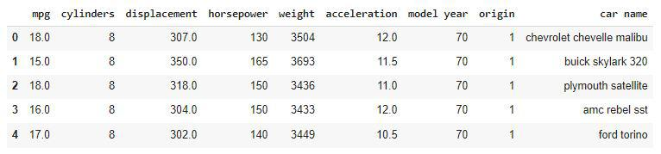

**Fig 3.1**

“Here we have imported the data’s from the CSV file”

df.shape



**Fig 3.2**

**“**Here there are 398 rows & 9 columns **”**

df.info()

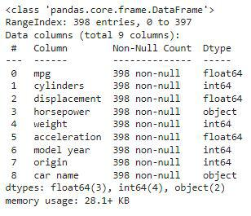

**Fig 3.3**

**“**Here we can observe one discrepancy the horsepower is given in the object datatype whereas it should be in the numeric datatype**”**

df.describe()

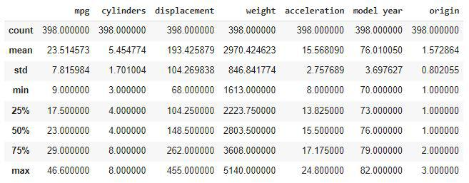

**Fig 3.4**

“This describes the mpg, weight, model year, cylinders, displacement, acceleration, origin for what’s the count, mean, std, min what’s the range at 25%, 50%, 75% & what’s the max range”

df['horsepower'].unique()

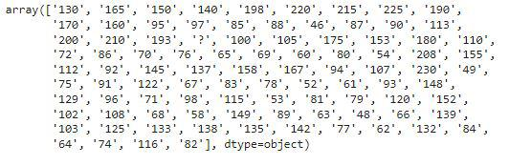

**Fig 3.5**

“Here we can observe that instead of the null they have been replaced by the string ‘?’ due to this, the data of this column has been provided in the object datatype.”

print(df.shape)

df = df[df['horsepower'] != '?']

print(df.shape)

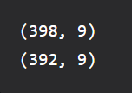

**Fig 3.6**

**“**So, there were 6 such rows with a question mark**.”**

df['horsepower'] = df['horsepower'].astype(int)

df.isnull().sum()

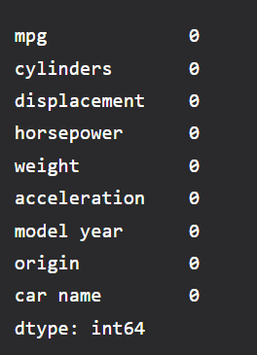

**Fig 3.7**

“Here all the data’s are made 0”

df.nunique()

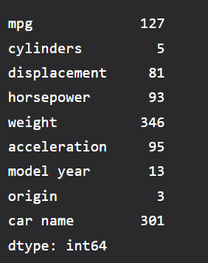

**Fig 3.8**

**“**These are the unique values**”**

plt.subplots(figsize=(15, 5))

for i, col in enumerate(['cylinders', 'origin']):

plt.subplot(1, 2, i+1)

x = df.groupby(col).mean()['mpg']

x.plot.bar()

plt.xticks(rotation=0)

plt.tight_layout()

plt.show()

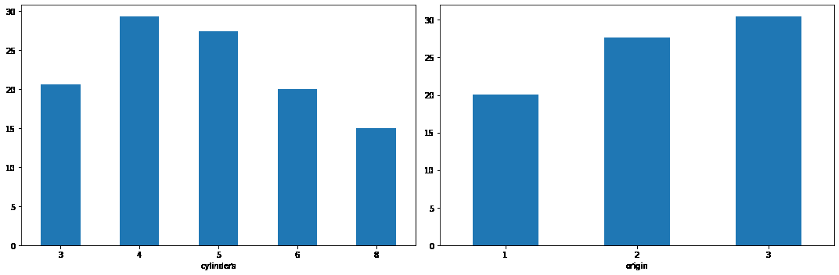

**Fig 3.9**

“This graph represents the number of cylinder versus their quantity & origin”

plt.figure(figsize=(8, 8))

sb.heatmap(df.corr() > 0.9,

annot=True,

cbar=False)

plt.show()

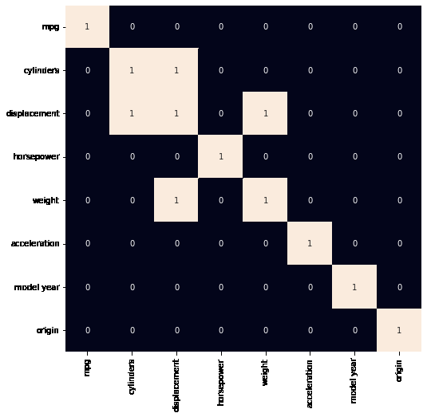

**Fig 3.10**

“If we will remove the displacement feature then the problem of high collinearity will be removed.”

df.drop('displacement',

axis=1,

inplace=True)

**Data Input Pipeline :**

from sklearn.model_selection import train_test_split

features = df.drop(['mpg', 'car name'], axis=1)

target = df['mpg'].values

X_train, X_val, \

Y_train, Y_val = train_test_split(features, target,

test_size=0.2,

random_state=22)

X_train.shape, X_val.shape

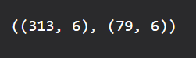

**Fig 3.11**

AUTO = tf.data.experimental.AUTOTUNE

train_ds = (

tf.data.Dataset

.from_tensor_slices((X_train, Y_train))

.batch(32)

.prefetch(AUTO)

)

val_ds = (

tf.data.Dataset

.from_tensor_slices((X_val, Y_val))

.batch(32)

.prefetch(AUTO**)**

**)**

**Model Architecture :**

“We will implement a model using the Sequential API of Keras which will contain the following parts:

We will have two fully connected layers.

We have included some BatchNormalization layers to enable stable and fast training and a Dropout layer before the final layer to avoid any possibility of overfitting.

The final layer is the output layer.”

model = keras.Sequential([

layers.Dense(256, activation='relu', input_shape=[6]),

layers.BatchNormalization(),

layers.Dense(256, activation='relu'),

layers.Dropout(0.3),

layers.BatchNormalization(),

layers.Dense(1, activation='relu')

])

“While compiling a model we provide these three essential parameters:

optimizer – This is the method that helps to optimize the cost function by using gradient descent.

loss – The loss function by which we monitor whether the model is improving with training or not.

metrics – This helps to evaluate the model by predicting the training and the validation data”

model.compile(

loss='mae',

optimizer='adam',

metrics=['mape']

)

model.summary()

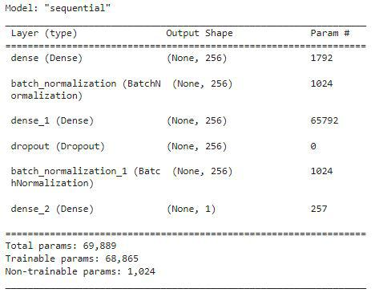

**Fig 3.12**

“It’s the summary of the model’s architecture”

**Model Training :**

Now we will train our model using the training and validation pipeline

history = model.fit(train_ds,

epochs=50,

validation_data=val_ds)

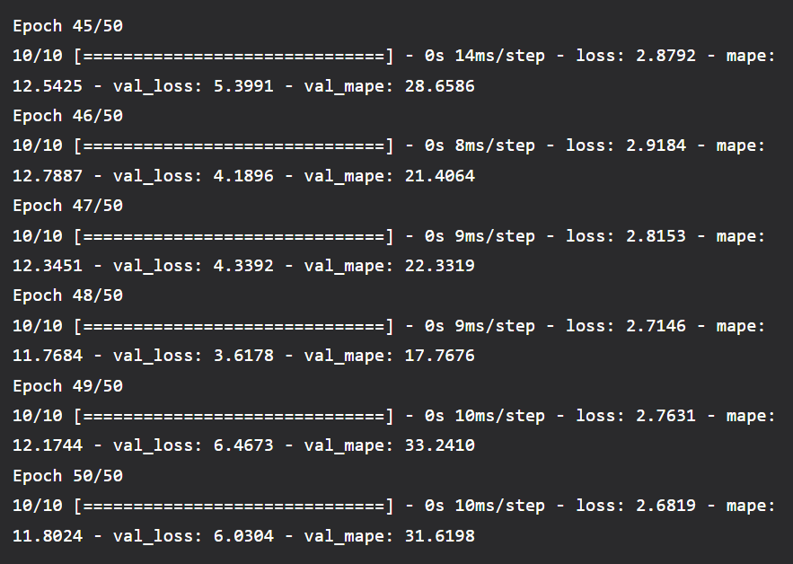

**Fig 3.13**

“Data of Epoch, here there are 5 Epoch with their estimation”

history_df = pd.DataFrame(history.history)

history_df.head()

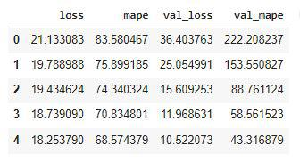

**Fig 3.14**

“Data frame of history”

history_df.loc[:, ['loss', 'val_loss']].plot()

history_df.loc[:, ['mape', 'val_mape']].plot()

plt.show()

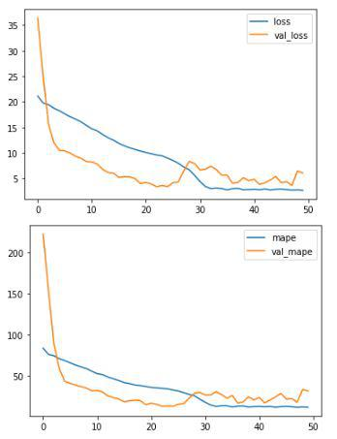

**Fig 3.15**

“The top graph represents the loss & val_loss and the bottom graph represents mape & val_mape ”

**CHAPTER.4**

**4.SKILLS ACQUIRED**

The following are the skills acquired through the four weeks internship programme:

* Fundamentals Python programming.
* Learned to do various examples on Jupiter Notebook.
* Usage of Python packages like Numpy, Pandas, Matplotlib etc.
* Accessing of data sets learned during internship.
* Working with csv files using python
* Understand, evaluate, design and impel

#### Machine learning :

#### A method of data analysis that automates analytical model building. It is a branch of artificial intelligence based on the idea that systems can learn from data, identify patterns and make decisions with minimal human intervention.

#### Artificial intelligence (AI) :

Refers to the simulation of human intelligence in machines that are programmed to think like humans and mimic their actions. The term may also be applied to any machine that exhibits traits associated with a human mind such as learning and problem-solving, the goals of artificial intelligence include learning, reasoning, and perception

**TensorFlow :**

TensorFlow is an open-source machine learning framework developed by Google. It is designed to facilitate the development and deployment of deep learning models for a wide range of applications, from image and speech recognition to natural language processing and more. TensorFlow offers a flexible and scalable platform for building neural networks and other machine learning models, making it a popular choice for both research and industry.

1. **CONCLUSION**

Predicting fuel efficiency using TensorFlow in Python has provided valuable insights into the world of machine learning and its real-world applications. By harnessing the power of deep learning models, we've demonstrated the ability to accurately forecast a vehicle's fuel efficiency based on various input parameters. This not only enhances our understanding of fuel consumption but also paves the way for more sustainable and eco-friendly transportation solutions. The successful implementation of our predictive model serves as a testament to the robustness of TensorFlow as a tool for complex data analysis. With further refinements and larger datasets, we can aspire to create even more precise and practical fuel efficiency prediction systems, ultimately contributing to a greener and more energy-efficient future.